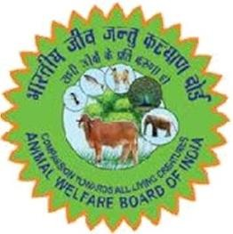ANIMAL WELFARE BOARD OF INDIA

Ministry of Fisheries, Animal Husbandry and Dairying, Govt. of India (Department of Animal Husbandry and Dairying)

NIAW Campus, 42 KM Mile Stone, Delhi-Agra Highway NH-2, Ballabhgarh, Haryana-121004

Email: [support-awbi@gov.in](mailto:support-awbi@gov.in) : Website: [www.awbi.gov.in](http://www.awbi.gov.in)

# APPLICATION FORM FOR COLONY ANIMAL/BIRD CARE TAKER

|  |  |  |  |  |
| --- | --- | --- | --- | --- |
| 1 | Name of the Applicant | | | *<Full Name>* |
| 2 | Name of Father / Spouse | | |  |
| 3 | Date of Birth | | |  |
| 4 | Gender | | |  |
| 5 | ID Proof | | |  |
|  | Document Type *(Aadhaar/Driving License/Voter ID/Passport)* | | |  |
|  | Document Number | | |  |
|  | Copy of ID Proof document | | |  |
| 6 | Complete Address *(with State, District, Taluka and Pin code)* | | |  |
| 7 | Mobile No. | | |  |
| 8 | Email ID | | |  |
| 9 | Name of the Recommending Authority | | |  |
| 10 | Recommendation Letter *(With signature and seal) (Member, AWBI/Co-opted Member for Sub Committee of AWBI/ Member of State Animal Welfare Board/ Honorary Animal Welfare Representative of AWBI/District Animal Husbandry Officer/District SPCA)* | | |  |
| 11 | Details of Feeding Area | | | |
|  | Name of the Area/Society | Address of the Area/Society | Does RWA Exist? (Yes/No) | Feeding Point Designated? (Yes/No) |
|  |  |  |  |  |